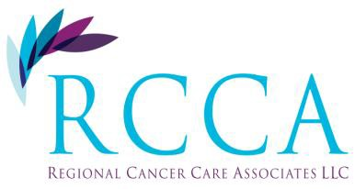Regional Cancer Care Associates LLC

Sparta Division

89 Sparta Ave, Suite 130

Sparta, NJ 07871

Phone: 973-726-0005

Fax: 973-726-4668

Dr. Bohdan Halibey, MD

Dr. May Abdo-Matkiwsky, DO

Dr. Jumana Chatiwala, MD

Attn: Regional Cancer Care Associates, LLC Patients

It is extremely important that you advise us if your insurance is changing effective January 1, 2015. We need this information to verify your insurance benefits and obtain prior authorization, if need be for treatment. Without a prior authorization, treatment may be held up. If we are not aware of an insurance change and your insurance carrier does not reimburse us, the balance will fall under the patients’ responsibility.

Please be advised it is the patients’ responsibility to know their benefits and understand their coverage. This includes referrals. If your plan requires referrals, it is your responsibility to obtain one. If a referral is not obtained, you will need to reschedule your appointment.

Please refer to your new patient documents that you were given upon your initial appointment here at Regional Cancer Care Associates, LLC.

Thank you for your understanding.

Best Regards,

The Billing Department

_______________________________ _____________________

Patients Signature Date